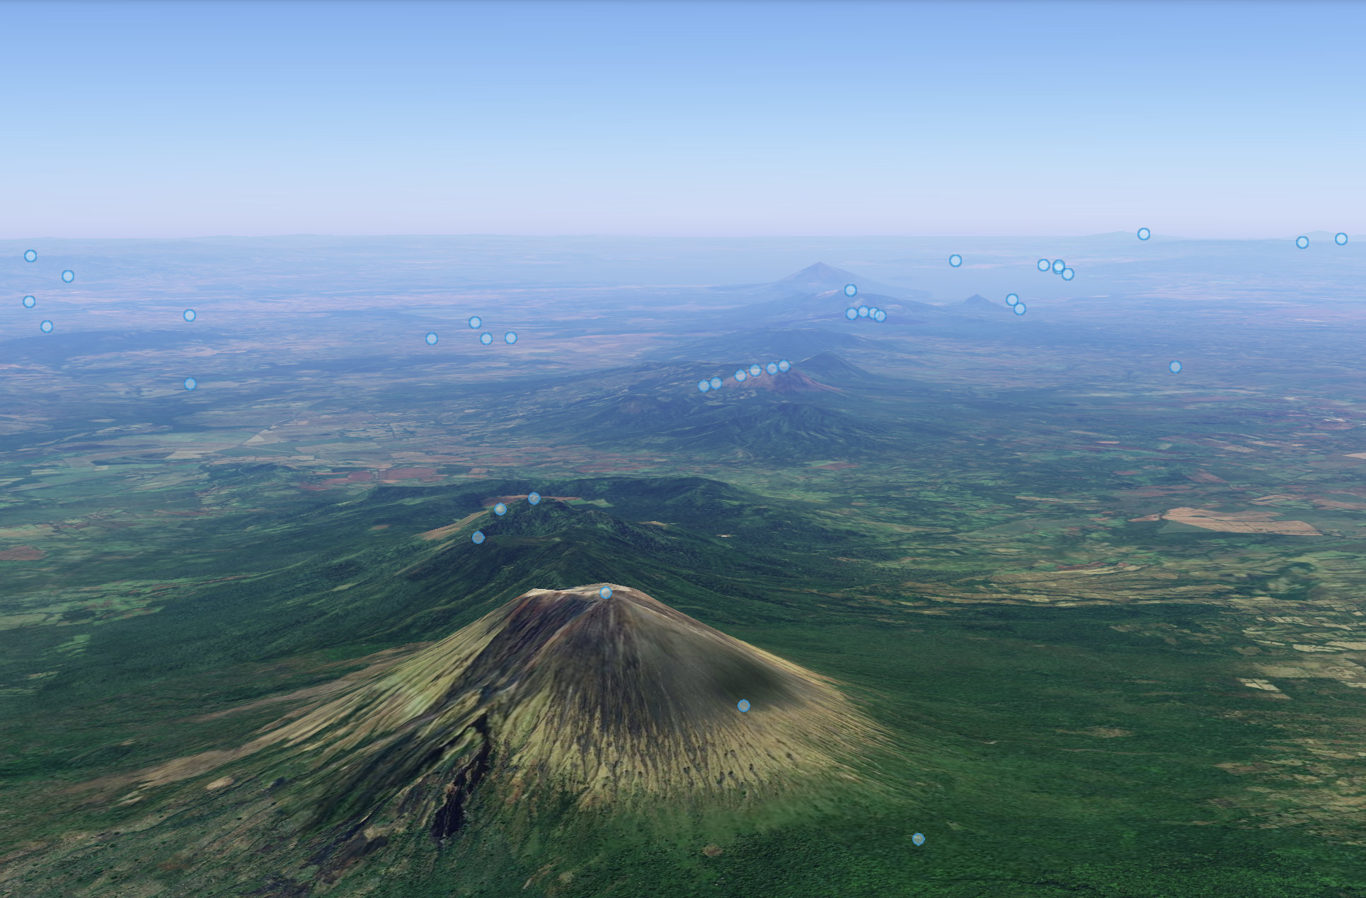

# **Adventure Trekking Challenge: The Line of Fire**

# **6 Volcanoes in 6 Days**

# **Elevation: 8,112 meters. Distance: 65 km (approx.)**

# **The Adventure of a Lifetime**

Embark on an unforgettable journey through Nicaragua's dramatic volcanic landscape in the **Adventure Trekking Challenge: The Line of Fire**. This once-in-a-lifetime experience will push your limits as you summit six of Nicaragua’s most iconic volcanoes in just six days, conquering a total elevation gain of **8,112 meters** over approximately **65 kilometers**.

This challenge is not for the faint of heart. It’s designed for those who seek to push their physical and mental boundaries in some of the world’s most unique environments. From the towering peaks of **San Cristóbal** and **Momotombo** to the lush cloud forests of **Mombacho** and the perfect cone of **Concepción**, you’ll experience the full range of Nicaragua’s stunning geography.

With each step, you’ll encounter breathtaking landscapes, from dry tropical forests to verdant cloud forests and vast volcanic craters. Along the way, you’ll be guided by experienced trekkers and supported by a dedicated team to ensure your safety and comfort.

This trek is not just about the physical challenge. It’s about immersing yourself in Nicaragua’s rich culture and natural beauty. From the vibrant city of **León** to the colonial charm of **Granada**, and the tranquility of **Ometepe Island**, every day will bring a new adventure.

Are you ready to push yourself to the limit, explore untouched wilderness, and conquer six volcanoes in six days? This is your chance to experience the raw beauty and exhilarating challenge of Nicaragua’s volcanic backbone. Let the adventure begin!

# **Arrival and Your Epic Journey Begins!**

**Fly into Managua**

Your adventure begins with your arrival at Managua International Airport. Our friendly team will greet you and transport you to the vibrant city of León, where you’ll settle in at the charming [La Recolección Hotel](https://www.examplehotel.com).

A boutique hotel that blends colonial elegance with modern comfort. You’ll enjoy a restful night before embarking on the thrilling volcano challenge. Its central location allows easy access to the León Cathedral, vibrant markets, and historic sites.

# **Day-by-Day Trekking Details**

## **Day 1: Ascend the Fiery Telica Volcano for a stunning sunset and evening descent**

Telica is one of Nicaragua’s most active volcanoes, offering an exhilarating start to your adventure. The trek takes you through dry tropical forests where the landscape is stark yet beautiful. As you ascend, the vegetation becomes sparse, giving way to rugged volcanic terrain.

| **Elevation (meters)** | **Distance (km)** | **Duration (hours)** | **Highest Gradient** | **Difficulty** |
| --- | --- | --- | --- | --- |
| 1061 | 8-10 | 4-6 | 35% | Medium |

**Day 2: Conquer San Cristóbal Volcano**

San Cristóbal is Nicaragua’s tallest volcano, and this trek takes you through lush forests before transitioning to loose volcanic ash and rocks as you ascend. The 45% gradient poses a challenge, but the summit rewards you with sweeping panoramic views of the Pacific Ocean and surrounding volcanoes.

| **Elevation (meters)** | **Distance (km)** | **Duration (hours)** | **Highest Gradient** | **Difficulty** |
| --- | --- | --- | --- | --- |
| 1750 | 10-12 | 6-8 | 45% | High |

**Day 3: Tackle the Mighty Momotombo Volcano**

The steep slopes and loose volcanic rock of Momotombo make this one of the most difficult climbs in the challenge. The 50% gradient demands both physical and mental endurance, but the stunning views of Lake Managua from the summit are a fitting reward for your effort.

| **Elevation (meters)** | **Distance (km)** | **Duration (hours)** | **Highest Gradient** | **Difficulty** |
| --- | --- | --- | --- | --- |
| 1297 | 10-12 | 7-9 | 50% | High |

**Move Base to Granada**

After three days in León, you’ll move to Granada, one of the oldest cities in the Americas. Stay at [La Merced Hotel](https://www.examplehotel.com). This colonial gem offers modern amenities and iconic pool in a beautiful historic building. With its quiet courtyards and proximity to the city’s vibrant streets it’s a perfect place to rest.

**Day 4: Race Up Mombacho Volcano and take on the 2km Canopy Tour**

Mombacho offers a unique experience with a 5 km time trial through lush cloud forests. The misty environment and the challenge of a time trial make this a fast-paced, exhilarating day. The summit provides panoramic views of Granada and Lake Nicaragua.

| **Elevation (meters)** | **Distance (km)** | **Duration (hours)** | **Highest Gradient** | **Difficulty** |
| --- | --- | --- | --- | --- |
| N/A (5 km Time Trial) | 5 | Half-day | 40% | Medium |

On the way back down take on the thrilling 2km long zip-lining adventure through the lush cloud forest of Mombacho. Keep an eye out for wildlife like howler monkeys and colorful tropical birds.

**Move Base to Ometepe Island**

After exploring Granada, take a ferry to Ometepe Island, home to two iconic volcanoes. Stay at [Hotel Villa Paraíso](https://www.examplehotel.com). Nestled on the shores of Lake Nicaragua, this lakeside retreat offers rustic charm and modern amenities. The perfect base for exploring Ometepe’s natural wonders, it is surrounded by lush gardens and offers easy access to hiking trails, waterfalls, and wildlife.

**Day 5: Conquer Maderas Volcano on Ometepe Island**

A beautiful and challenging trek, Maderas combines physical effort with the tranquility of a crater lake. The trails can be slippery, and the ascent requires endurance. However, the serene crater lake at the summit offers a peaceful reward for the day’s effort.

| **Elevation (meters)** | **Distance (km)** | **Duration (hours)** | **Highest Gradient** | **Difficulty** |
| --- | --- | --- | --- | --- |
| 1394 | 12-14 | 6-8 | 45% | High |

**Day 6: Summit the Majestic Concepción Volcano**

The most difficult climb of the week, Concepción is the perfect final test with its steep 55% gradient and loose volcanic rock. The ascent is tough, but reaching the summit rewards you with breathtaking views of Ometepe Island and Lake Nicaragua.

| **Elevation (meters)** | **Distance (km)** | **Duration (hours)** | **Highest Gradient** | **Difficulty** |
| --- | --- | --- | --- | --- |
| 1610 | 15-18 | 8-10 | 55% | High |

**Final Day: Relax and Explore!**

**Final Day: Relax and Explore!**

After six days of trekking, the final day offers a combination of relaxation and adventure.

**Afternoon: Drinks Overlooking Laguna de Apoyo**

Relax at Laguna de Apoyo, a serene volcanic crater lake known for its crystal-clear waters and peaceful surroundings. Sip a refreshing drink at a lakeside café while soaking in panoramic views of the lake and volcanos.

**Evening: Visit Volcán Masaya’s Fiery Lava Lake**

As the day comes to a close, head to Volcán Masaya for a final volcanic experience. From a safe viewing platform at the crater’s edge, witness the rare sight of molten lava glowing beneath the surface. Feel the heat radiating from the Earth and marvel at the raw power of nature. This unique and awe-inspiring experience provides a dramatic and unforgettable conclusion to your Nicaraguan adventure.

**FAQs: Adventure Trekking Challenge – The Line of Fire**

**1. What level of fitness is required for this challenge?**

This trek is physically demanding and requires a **high level of fitness**. Participants should be in good physical shape and have prior experience in long-distance hiking or trekking. The climbs can be steep, with some days requiring up to **8-10 hours** of hiking at high gradients. Training in endurance and strength will help you prepare for the challenge.

**2. How difficult are the volcano climbs?**

The difficulty level of the volcanoes varies:

* Some days, like **Telica** and **Mombacho**, are considered **medium** difficulty, with manageable distances and gradients.
* Other days, such as the climb to **Momotombo** and **Concepción**, are more intense, with gradients reaching up to **55%** and rocky terrain. These climbs require stamina, mental toughness, and careful footing on loose volcanic rock.

**3. What should I pack for the trek?**

Here’s a general packing list:

* **Hiking boots** with good ankle support and traction
* **Layered clothing** (temperatures vary with altitude)
* **Waterproof jacket** and gear (for unexpected rain)
* **Sunscreen**, sunglasses, and a hat (for sun protection)
* **Backpack** for daily essentials
* **Hydration packs or water bottles**
* **Snacks and energy bars** for long trekking days
* **Headlamp** or flashlight (especially for pre-dawn hikes)
* A **first-aid kit** with blister care, pain relievers, and any personal medication

**4. Will there be altitude sickness, and how do we handle it?**

While the altitudes on these volcanoes aren’t extremely high (the highest peak, **San Cristóbal**, is 1750 meters), some participants may still feel the effects of altitude, particularly on more strenuous days. Common symptoms include shortness of breath, headaches, or fatigue.

To prevent altitude sickness:

* **Stay hydrated** by drinking plenty of water.
* Take breaks and **ascend slowly** to allow your body to adjust.
* Let your guides know if you feel unwell; they are trained to handle such situations.

**5. What is the weather like during the trek?**

The trek takes place during **Nicaragua’s dry season**, typically in February, when the weather is warm and dry. Daytime temperatures range from **27°C to 32°C (81°F to 90°F)**, while nights, especially at higher elevations, can drop to around **18°C to 22°C (64°F to 72°F)**. Be prepared for some variation in temperature, particularly during the early morning or late evening treks.

**6. What kind of accommodation is provided?**

Throughout the trek, you’ll stay in **comfortable hotels and lodges**:

* **La Recolección Hotel** in León offers colonial charm and modern amenities, providing a relaxing stay after your first few trekking days.
* In **Granada**, you’ll stay at **La Merced Hotel**, a beautiful colonial hotel close to key historic landmarks.
* On **Ometepe Island**, you’ll be based at **Hotel Villa Paraíso**, a peaceful lakeside retreat with easy access to hiking trails.

**7. Are meals included in the trip?**

Yes, **breakfast is included** during the trek. These meals are designed to provide energy for the day ahead, with a focus on local and nutritious options. **Lunches and dinners** will be at your own expense, but we will provide recommendations for local restaurants and cafés along the route where you can enjoy delicious Nicaraguan cuisine.

**8. What if I have dietary restrictions?**

Most **dietary restrictions** can be accommodated, such as vegetarian, vegan, gluten-free, or other specific needs. Please inform us of any dietary requirements before the trip so we can make the necessary arrangements.

**9. What is the group size for the trek?**

To ensure a personalized experience, the group size is limited to 6-**10 participants**. This allows for better group dynamics, easier communication with guides, and the flexibility to manage varying fitness levels and paces within the group.

**10. What kind of support will I have during the trek?**

You will be accompanied by **experienced trekking guides** who are knowledgeable about the terrain and local conditions. Additionally, **support staff** will assist with logistics, including transportation, meals, and accommodation. Safety is our top priority, and we have **first-aid trained guides** and **communication equipment** available at all times.

**11. Will I have access to clean water during the trek?**

Yes, there will be access to **safe drinking water** throughout the trek. We encourage participants to bring reusable water bottles or hydration packs. Regular water stops will be arranged, especially on the longer hiking days.

**12. Do I need vaccinations for Nicaragua?**

While there are no mandatory vaccinations for entry into Nicaragua, the **Centers for Disease Control and Prevention (CDC)** recommends that travelers be up to date on routine vaccines such as **MMR (measles, mumps, rubella)**, **diphtheria-tetanus**, and **influenza**. Additionally, it’s advised to consider vaccines for **Hepatitis A**, **Typhoid**, and, if you plan on extending your stay in remote areas, **Malaria prevention**. Consult your healthcare provider at least 6-8 weeks before departure.

**13. Are there any immigration requirements for Nicaragua?**

Travelers to Nicaragua need to have a **valid passport** with at least six months’ validity from the date of entry. Some nationalities require a **visa** for entry, while others may enter on a **tourist card**, which is available upon arrival at the airport for a $10 (cash only). Make sure to check your country’s specific requirements before traveling. It is also recommended to have a **return ticket** or proof of onward travel to avoid issues at immigration.

**14. Is Nicaragua safe for travelers?**

Nicaragua is generally considered **safe for tourists**, especially in popular trekking areas such as **León**, **Granada**, and **Ometepe Island**. However, as with any international travel, it’s important to remain cautious. Here are a few safety tips:

* Keep your **valuables secure** and avoid carrying large amounts of cash.
* Stay aware of your surroundings in crowded areas.
* Follow the advice of your trekking guides, particularly in more remote areas.

We also recommend enrolling in your country's **travel advisory program** to stay updated on any potential safety issues.

**15. Is travel insurance required?**

Yes, **travel insurance** is required for all participants. The insurance should cover **medical expenses, emergency evacuation**, and **trip cancellations**. Please ensure your policy is up to date and provides adequate coverage for an adventure-based trip in remote areas.

**16. What’s the cancellation policy?**

Cancellations made **30 days or more** before the trek will receive a **full refund**. Cancellations made **within 0-30 days** of the trek will receive a **75% refund**. No refunds will be issued for cancellations made on the start date or after the trek has commenced.

**17. How do I book the trek?**

You can book your **Adventure Trekking Challenge** directly through our website or by contacting our customer support team. After booking, you will receive a confirmation email with further details and a checklist to help you prepare for your journey.