Vietnamese Entry #1:
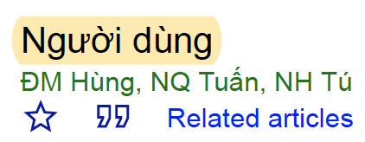
Vietnamese Entry #2:
